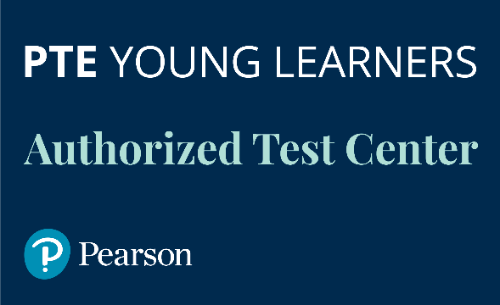
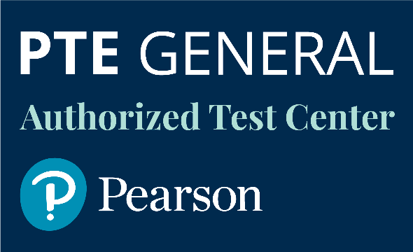

CRITERIA
- MIN 25 CANDIDATES PER YEAR
The PTE Test Centre must guarantee a minimum of 25 candidates per year with further increase in numbers of candidates.
- CANDIDATE FORECAST
The PTE Test Centre must provide a forecast of candidate numbers for every PTE session.
- LEGAL/OFFICIAL BODY
The PTE Test Centre must be legally formulated organizations with official status.
- PREMISES
The PTE Test Centre must provide suitable premises for each exam session.
- EXAMINERS/INTERLOCUTORS/ADMINISTRATORS
The PTE Test Centre must provide their own examiners, interlocutors and administrators. All such staff are required to undertake special trainings.
- PTE CANDIDATES PREPARATION COURSE
The PTE Test Centre is obliged to run PTE preparation courses for candidates using Pearson accredited materials.
- PROMOTION
The PTE Test Centre must promote PTE on its website, any social media channels and through printed materials.

WHAT YOU RECEIVE
- BRANDED PLAQUE
The PTE Test Centre will receive a special branded plaque.
- EXAMINATION CENTRE NUMBER
The PTE Test Centre will be accredited by Pearson UK and awarded the official test centre along with the PTE Examination Centre number,.
- PEARSON BRANDING
The PTE Test Centre will be granted the right to use Pearson branding.
- SPECIALLY DISCOUNTED EXAMINATION FEES
The PTE Test Centre will get 15% discount on PTE exams price.
- SPECIAL DISCOUNTS ON PEARSON BOOKS
The PTE Test Centre will get a discount on exam preparation Pearson books.

- METHODOLOGICAL SUPPORT
The PTE Test Centre will receive free methodological support during the first year of test centre status. This support includes trainings for examiners, interlocutors and centre administrators.
- CONSULTANCY
The PTE Test Centre will receive consultations and all necessary information from Dinternal Education as long as it holds PTE exams.

